# **HOW TO INSTALL ZABBIX AGENT AND ADD WINDOWS HOST TO ZABBIX MONITORING**

1. Download latest windows zabbix agent source code from zabbix official site: <https://www.zabbix.com/download_agents>
2. Create a folder in C drive with name zabbix( free to choose another drive or path)
3. Copy “zabbix_agentd.exe” from downloaded dir in to the newly created foder in C drive (in zabbix folder)

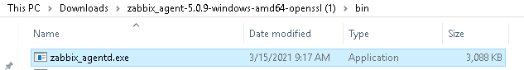

1. Copy “zabbix_agentd.conf” from downloaded dir. in to the newly created foder in C drive (in zabbix folder)

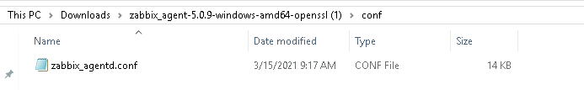

1. After copy , your zabbix directory will look like below

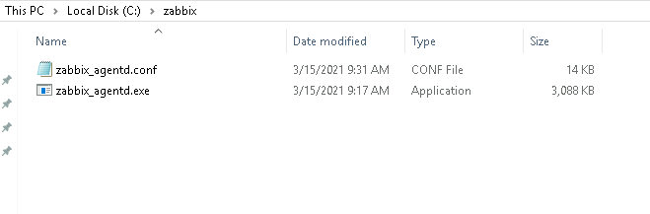

1. now Edit “zabbix_agent.conf” and find for “Server” word then write there your zabbix server IP, Like below

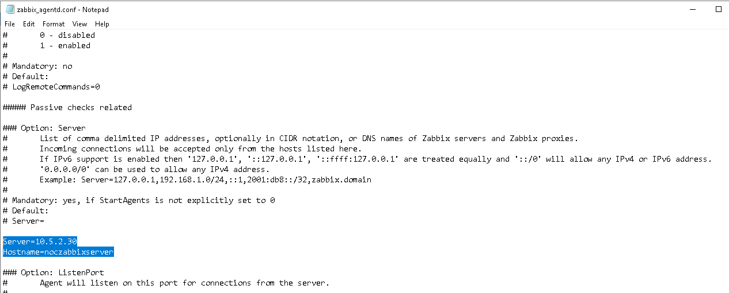

NOTE:- Hostname not mendotory**

1. Now open CMD then execute below command ( be carefull about your given path)

#cd c:

#cd zabbix

#zabbix_agentd.exe -c zabbix_agentd.conf --install

OUTPUT:

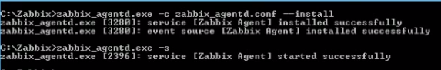

#zabbix_agentd.exe -s **(To start zabbix service)**

1. Then open “services.msc” and check zabbix service is running or not
2. Finally add your host in zabbix.